 |  | ICEPOD  Campaign: AN04
FLIGHT REPORT
Flight Number: | AN04_F1008 |  | Line Number: |  |  | PIPERS2
Date: | 22 November 2017 (UTC) Wednesday 22 Nov 2017 PM (local)
Prepared by: | Tinto
Takeoff time: | 0737 (UTC) |  |  | Land time: | 1433 (UTC)
Duration: | 6.9 hrs

DATA SUMMARY
Instrument | Operated | QC | Notes
POD-INS (SPAN) | Y
HATCH-GNSS (LEICA_air) | N | - | Operator error
DGS-INS | Y
iMAR-INS | Y
BASE1 (Leica ground) | N
GRAVITY DgS | Y
GRAVITY ZLS | Y
RADAR DICE | N | N | Not operated – sea ice flight.
RADAR SIR | Y | Y
MAG AIR | Y | Y | Cs3 spontaneously worked
MAG BASE | Y | Y
LIDAR | Y | Y | TOWN PASS – features are skewed again (see F1006)
KT15 | Y | -
BOBCAT | Y | Y | Archive failed for second half of flight – first half OK
IRE | Y | N | Archive failed for second half of flight – flight disk possibly compromised
DGU | Y | Y

FLIGHT TRACK
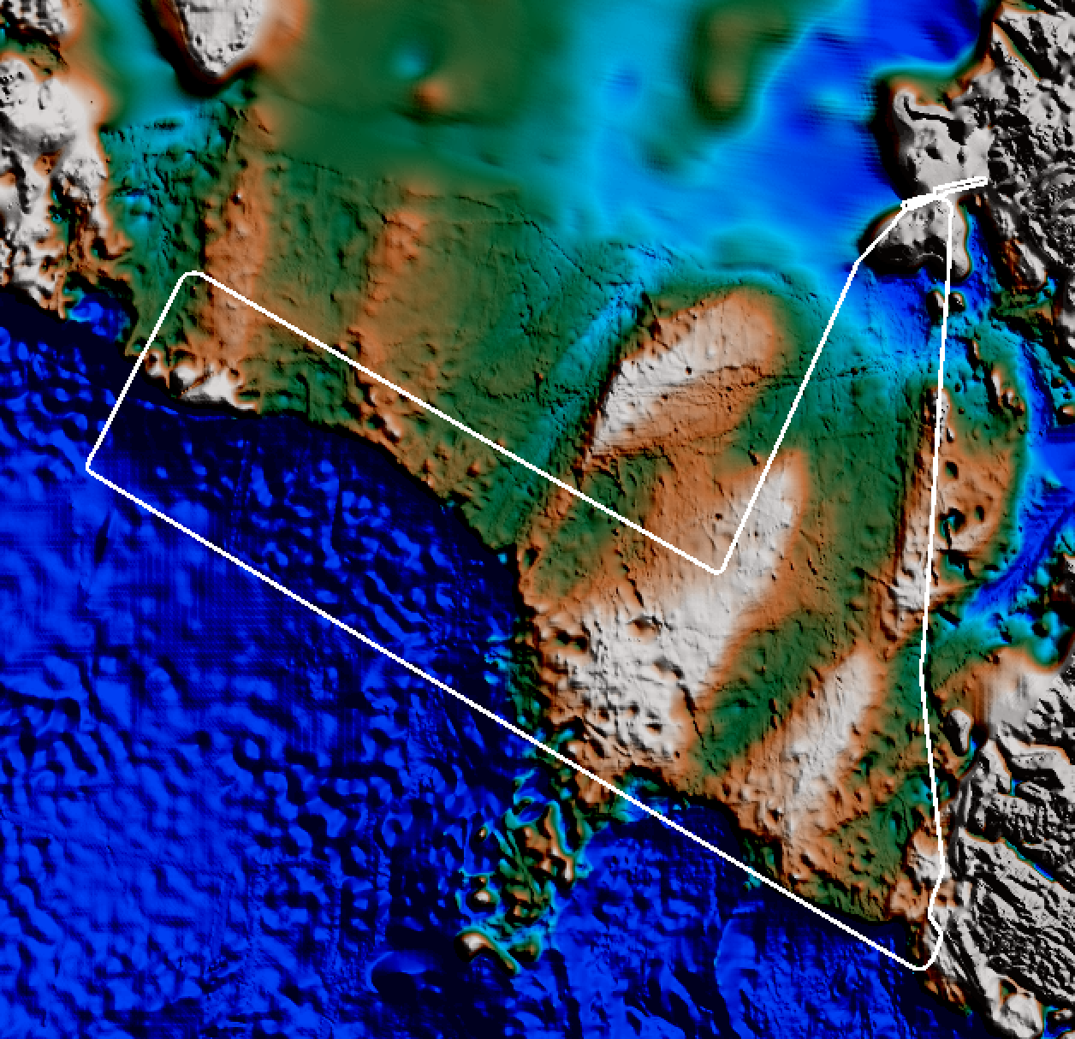

Notes

Preflight
PIPERS flight with Hongjie Xie and 2 others flying.
Nut from stabilizing bolt connecting pod and arm structures discovered to be missing in pre-flight checks. Replacement installed before flight.

Flight
Cloud encountered in second half of first line, moved to come home on second line (also part of oib2013 track).

Postflight
IRE disks required repair before archiving – data may be lost.
Mag data require further scrutiny – data present but possible influence of plane motion…

